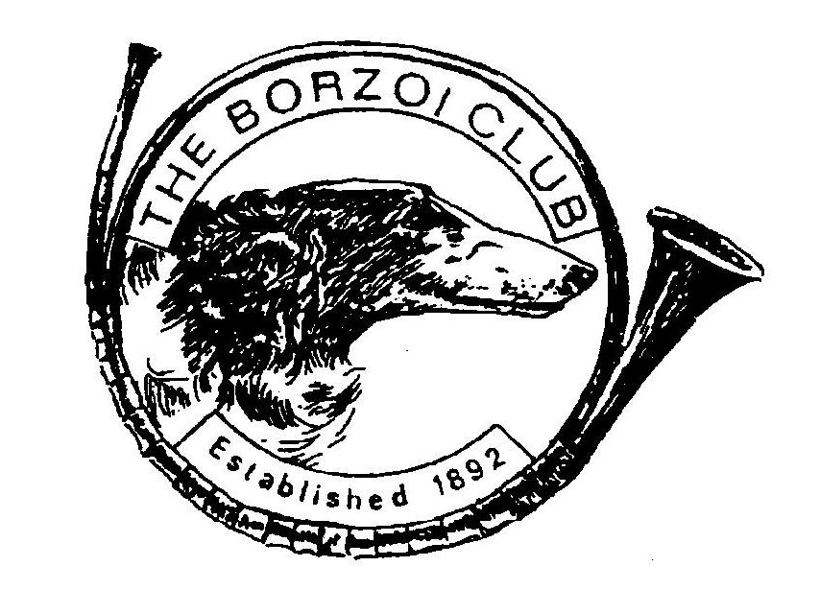
BORZOI CLUB YEARBOOK 2023

To get the best from your insert please follow these guidelines:

- Inserts can be submitted in writing with photos, digitally via email or in any combination.
- If submitting digitally please use a high resolution for your photographs.
- Fully formatted adverts can be sent as MS Word or PDF files and will be printed as sent subject to the following: please remember that the yearbook is A5 size and space must be left on all four sides to allow for margins and page numbers etc. Please name the file with your affix or surname and the number of pages - e.g. myaffix2pages.doc or myname1page.pdf.
- Please ensure that all copy is very clear - if handwritten please use BLOCK CAPITALS and spell all dogs names carefully. Please remember that this is A5 size so if it looks good on A4 it might well look cramped on A5. Photographs will be resized to give as large an image as possible allowing for the text required.
- We can help with formatting but an idea of what you want would be useful !!!
- Only show results from 2023 to be included
- Proofs will only be sent if you advise an email address to be used or enclose a stamped addressed envelope.
- Pages in the insert section will be numbered separately from the main part of the book allowing for an index page. Inserts will therefore NOT be in alphabetical order and every effort will be made to ensure that where multiple pages are booked they are printed on facing pages.

NOTE: CC / RCC section is for CC & RCC U.K. awards only, no foreign awards to be listed.

Challenge Certificate £5 per dog Photograph, name of dog and number of
Winners CCs (plus RCCs if applicable) won
during 2023 NO LOGOS, AFFIXES OR TEXT TO BE PUT ON PHOTOGRAPHS

Reserve CC winners £5 per dog Photograph, name of dog and number
of RCCs won during 2023 only.
NO LOGOS, AFFIXES OR TEXT TO BE PUT ON PHOTOGRAPHS

All inserts and submissions for the CC and RCC winners sections MUST BE PRE-PAID i.e. BEFORE GOING TO THE PRINTERS. Please supply numbers of CCs / RCCs with your photographs.

YEARBOOK PRICES

Inserts:

Single page: £25

Two pages: £45

Three pages: £65

Four pages: £84

Please Note: there will be no additional charge for extra photographs on your pages but please be aware that too many could affect the quality.

For inserts with more than four pages please apply to Pat Harris for details of charges:

Deadline for the receipt of inserts is Friday 23th February 2024 at the VERY VERY LATEST. If possible please send well in advance of this date.

Please send all inserts with PAYMENT to: Miss Pat Harris, 172 Allens Lane, Pelsall, Walsall WS3 4JP
Email: the borzoiclub@ymail.com or emails only to Mrs Lorraine Harvey info@theborzoiclub.org.uk

If you wish to pre-order your yearbook for collection at a show the cost will be £13 but if you require it to be posted (UK) please add £3.00 for post and packing.

THE COST OF THE 2023 YEARBOOK WILL BE £16 -

All inserts and submissions for the CC & RCC winners sections must be pre-paid. IF YOU ARE SUBMITTING BY EMAIL YOUR INSERTS WILL NOT BE PROCESSED UNTIL YOUR CHEQUE HAS BEEN RECEIVED OR YOU CAN PAY BY PAYPAL or BANK TRANSFER. Please make cheques payable to The Borzoi Club, payments in £ sterling only please. If you require a Paypal invoice please inform us and an invoice will be arranged or if you wish bank transfer then please contact Pat Harris for bank details

